

**GOVERNMENT COLLEGE OF ENGINEERING, AMRAVATI**

(An Autonomous Institute of Govt of Maharashtra)

**DEPARTMENT OF ELECTRONICS AND**  **TELECOMMUNICATION**

# A Project Report on

**FIRE ALARM SYSTEM**

Submitted By

# SURAJ RAUT - 20004037

STUDENT OF THIRD YEAR BACHLOR OF ELECTRONICS AND TELECOMMUNICATION ENGINEERING

Under Guidance of

**Dr. S.S. THAKARE**

PROFESSOR OF ELECTRONICS AND TELECOMMUNICATION DEPARTMENT

## 

## DEPARTMENT OF ELECTRONICS AND TELECOMMUNICATION

**GOVERNMENT COLLEGE OF ENGINEERING, AMRAVATI**

(An Autonomous Institute of Govt of Maharashtra)

# CERTIFICATE

Certified that seminar work entitled

**“Fire alarm system”** is a bonafide work carried out in the sixth semester by: SURAJ RAUT - 20004037

In partial fulfillment for the award B. Tech in Electronics and Telecommunication Engineering

from **GOVERNMENT COLLEGE OF ENGINEERING, AMRAVATI** during the academic year 2022-2023.

Signature of project guide

**Dr. S.S. Thakare**

Signature of HOD Signature of Principal

**Dr. P.R. Deshmukh Dr. A.M. Mahalle**

## ACKNOWLEDGEMENT

I thank the almighty for giving us the courage and perseverance in completing the main-project. I extend our sincere thanks to **Dr. A.M. Mahalle** principal of our college, for providing sufficient infrastructure and good environment in the college to complete our course. I would like to thank Head of the E.C.E. Department  **Dr. P.R. Deshmukh** for his constant encouragement.

I am greatly indebted to project guide **Dr. S.S. Thakare** Professor, Electronics and Communication Engineering, for providing valuable guidance at every stage of this project work. I am profoundly grateful towards the unmatched services rendered by her.

My special thanks to all the faculty of Electronics and Communication Engineering and peers for their valuable advises at every stage of this work. Last but not least, I would like to express my deep sense of gratitude and earnest thanks giving to my dear parents for their moral support and heartfelt cooperation in doing the main Project.

FIRE ALARM SYSTEM

**Abstract:**

This project focuses on the design and implementation of a fire alarm system using an IR sensor, Transistor 547, resistor, and battery for the detection of fire hazards. The primary objective is to develop an efficient and cost-effective fire detection system using readily available components.

The IR sensor serves as the main sensing element, capable of detecting infrared radiation emitted by fire. Once fire is detected, the IR sensor triggers an electrical signal. The Transistor 547 amplifies this signal, enabling effective activation of the alarm circuitry.

The resistor is incorporated to stabilize the electrical current in the circuit, ensuring proper functionality. The battery provides uninterrupted power supply, ensuring the system remains operational during power outages.

Through testing and evaluation, the fire alarm system has demonstrated its ability to promptly detect fire hazards and activate the alarm to alert occupants. Its simple design, utilization of affordable components, and reliable performance make it suitable for various applications, including residential and small-scale commercial environments.

Keywords: Fire alarm system, IR sensor, Transistor 547, Resistor, Battery, Fire detection, Cost-effective design, Reliable performance.

**Introduction:**

The Fire Alarm System project aims to design and implement an efficient fire detection system using an IR sensor, Transistor 547, resistor, and battery. The project focuses on developing a cost-effective solution to detect fire hazards and raise alarms promptly, ensuring the safety of occupants and minimizing potential damages.

Fire accidents can have devastating consequences, making early detection crucial for effective response. The IR sensor utilized in this project plays a vital role in detecting the presence of fire by sensing infrared radiation. Once fire is detected, it triggers an electrical signal that is amplified by the Transistor 547.

The resistor ensures the stability of the electrical current within the system, preventing any irregularities and maintaining proper circuit functionality. The battery serves as a reliable power source, ensuring uninterrupted operation of the fire alarm system even during power outages.

By combining these components, the project aims to create a simple and affordable fire alarm system that can promptly detect fire hazards and raise alarms to alert occupants. The system's cost-effective design and use of commonly available components make it suitable for various applications, ranging from residential homes to small commercial establishments.

The successful implementation of this fire alarm system will contribute to enhancing fire safety measures, providing an effective early warning system for fire detection, and enabling timely evacuation, minimizing potential risks associated with fire incidents.

**Principle of Working:**

The Fire Alarm System project operates based on the following principle:

1. Fire Detection: The IR sensor is the key component responsible for fire detection. It senses infrared radiation emitted by fire and detects the presence of a fire hazard. When the IR sensor detects the infrared radiation, it generates an electrical signal indicating the presence of fire.

2. Signal Amplification: The electrical signal from the IR sensor is then amplified by the Transistor 547. The transistor acts as an amplifier, increasing the strength of the signal for further processing.

3. Alarm Activation: Once the electrical signal is amplified, it triggers the alarm circuitry. The amplified signal is used to activate the alarm system, which may include components such as buzzers, sirens, or other acoustic indicators. The activation of the alarm alerts occupants of the potential fire hazard, prompting them to take immediate action.

4. Circuit Stability: The resistor is incorporated into the circuit to stabilize the electrical current flow. It helps prevent irregularities or fluctuations in the circuit, ensuring consistent and reliable performance of the fire alarm system.

5. Power Supply: The battery serves as a reliable power source for the fire alarm system. It provides uninterrupted power supply, allowing the system to operate even during power outages or disruptions.

Overall, the principle of working of the fire alarm system involves the IR sensor detecting infrared radiation emitted by fire, the Transistor 547 amplifying the signal, the alarm circuitry activating the alarm components, and the resistor ensuring circuit stability. The battery provides continuous power supply, enabling the system to detect fire hazards and raise alarms effectively.

By following this principle, the fire alarm system effectively detects fires, raises timely alarms, and enhances fire safety measures, protecting lives and property from potential fire incidents.

**Block diagram**:-

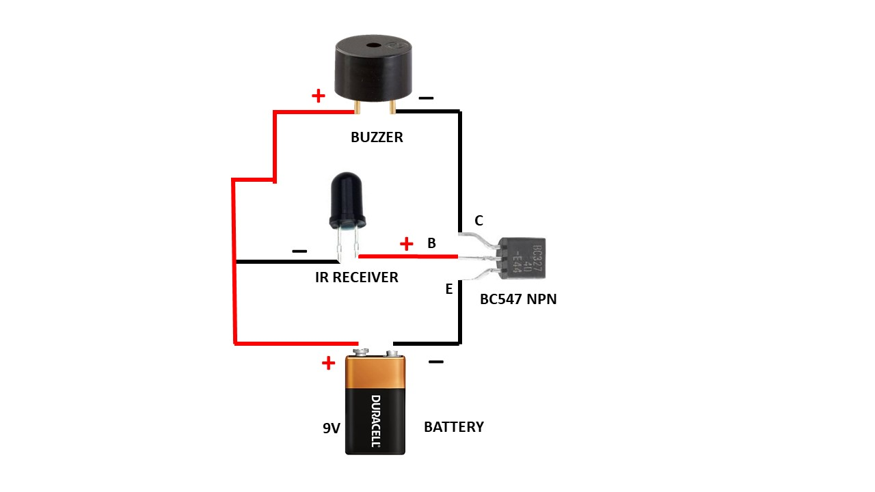

**Circuit Diagram** :-

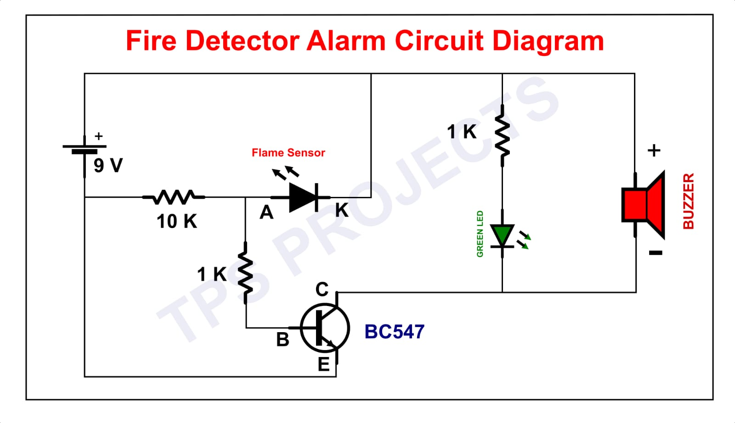

**Block diagram description :-**

The Fire Alarm System, designed using an IR sensor, Transistor 547, resistor, and battery, can be represented by the following block diagram:

1. IR Sensor: The IR sensor is the primary component responsible for detecting the presence of fire. It senses the infrared radiation emitted by fire and generates an electrical signal accordingly.

2. Signal Amplification: The electrical signal from the IR sensor is fed into the Transistor 547. The transistor acts as an amplifier, increasing the strength of the signal for further processing.

3. Alarm Circuitry: The amplified signal is then connected to the alarm circuitry. This circuitry includes a buzzer or other acoustic indicator. When the signal reaches a certain threshold, it triggers the alarm, generating a loud sound to alert occupants about the potential fire hazard.

4. Resistor: The resistor is incorporated into the circuit to stabilize the electrical current flow. It ensures that the circuit functions properly and prevents any irregularities or fluctuations in the signal.

5. Battery: The system is powered by a battery, which provides an uninterrupted power supply. The battery ensures continuous operation of the fire alarm system, even during power outages or disruptions.

The block diagram illustrates the flow of the fire alarm system, starting from the IR sensor's fire detection, followed by the signal amplification through the Transistor 547. The amplified signal is then used to activate the alarm circuitry, which includes the acoustic indicator. The resistor stabilizes the current flow, and the battery provides the necessary power for the system's operation.

This block diagram representation demonstrates the key components and their interconnections in the Fire Alarm System, highlighting the sequential flow of the system's operation for fire detection and alarm activation**.**

**Circuit diagram description :-**

Above circuit diagram is consist of various components such as

1. IR sensor
2. Transistor BC 547
3. Battery (9V)
4. Buzzer
5. Resistor

Buzzer have two terminals positive and negative terminal. The positive terminal is connected to to the positive terminal of battery and negative terminal is connected to the collector terminal of transistor(BC 547). Transistor BC 547 has three terminals and they are collector ,base and emmiter. Collector is connected to negative terminal of buzzer, base is connected to positive terminal of IR sensor. Emmiter is connected to negative terminal of battery.

**Working of the Fire Alarm System:**

The fire alarm system, made using an IR sensor, Transistor 547, resistor, and battery, is designed to detect and raise an alarm in the event of a fire. The working of the project involves the following steps:

1. Fire Detection: The IR sensor continuously monitors the surrounding area for infrared radiation emitted by fire. When it detects the presence of fire, it generates an electrical signal.

2. Signal Amplification: The electrical signal from the IR sensor is fed into the base of the Transistor 547. The transistor acts as an amplifier, increasing the strength of the signal.

3. Alarm Activation: The amplified signal from the transistor is used to activate the alarm circuitry. This circuitry includes a buzzer or other acoustic indicator. When the signal reaches a certain threshold, it triggers the alarm, producing a loud sound to alert occupants of the potential fire hazard.

4. Circuit Stability: The resistor is connected in the circuit to stabilize the electrical current. It ensures that the circuit functions properly and prevents any irregularities or fluctuations in the signal.

5. Power Supply: The system is powered by a battery, providing an uninterrupted power source. The battery ensures the continuous operation of the fire alarm system, even during power outages.

By following this working mechanism, the fire alarm system using an IR sensor, Transistor 547, resistor, and battery effectively detects the presence of fire and raises an alarm to alert occupants. The system provides an early warning, enabling timely evacuation and enhancing fire safety measures.

**Applications of the Fire Alarm System:**

The Fire Alarm System, built using an IR sensor, Transistor 547, resistor, and battery, has a wide range of applications in various settings. Some of the key applications include:

1. Residential Buildings: The fire alarm system can be installed in homes and apartments to provide early detection of fires, ensuring the safety of residents and minimizing property damage.

2. Commercial Buildings: Offices, retail stores, and other commercial establishments can benefit from the fire alarm system to detect fires and alert occupants, allowing for quick evacuation and preventing potential loss of life and assets.

3. Industrial Facilities: Manufacturing plants, warehouses, and industrial complexes can implement the fire alarm system to enhance fire safety measures. Early detection and timely alarms can help prevent major fire incidents and protect valuable equipment and materials.

4. Educational Institutions: Schools, colleges, and universities can utilize the fire alarm system to ensure the safety of students, staff, and visitors. Prompt fire detection and alarm activation aid in swift evacuation and emergency response.

5. Healthcare Facilities: Hospitals, clinics, and nursing homes can benefit from the fire alarm system to ensure the safety and well-being of patients, staff, and visitors. Early detection of fires can help prevent disruptions to critical healthcare services.

6. Hospitality Industry: Hotels, resorts, and guest accommodations can install the fire alarm system to provide a safe environment for guests. The system helps detect fires and notify occupants, allowing for timely evacuation and minimizing potential harm.

7. Public Spaces: Fire alarm systems can be installed in public spaces such as theaters, shopping malls, and recreational centers to protect the public from fire hazards and ensure their safety.

8. Transportation Systems: Fire alarm systems can be integrated into transportation infrastructures like airports, train stations, and bus terminals to detect fires and mitigate potential risks, safeguarding passengers and property.

The versatility of the fire alarm system makes it applicable in various settings where fire safety is paramount. By utilizing the IR sensor, Transistor 547, resistor, and battery, the system provides an effective early warning system for fire detection, ensuring timely response and mitigating the impact of fire incidents.

**Conclusion:**

In conclusion, the Fire Alarm System developed using an IR sensor, Transistor 547, resistor, and battery serves as an effective solution for detecting fires and alerting occupants in a timely manner. The project successfully achieves its objective of designing a cost-effective fire detection system using readily available components.

By utilizing the IR sensor, the system detects the presence of fire by sensing infrared radiation. The Transistor 547 amplifies the electrical signal from the IR sensor, ensuring reliable activation of the alarm circuitry. The resistor stabilizes the electrical current, while the battery provides uninterrupted power supply, ensuring continuous operation of the fire alarm system.

The implemented fire alarm system holds great significance in enhancing fire safety measures in various applications such as residential buildings, commercial establishments, industrial facilities, educational institutions, healthcare facilities, and public spaces. The early detection of fires and prompt alarm activation aids in evacuating occupants and minimizing potential risks to life and property.

The project's simplicity, cost-effectiveness, and utilization of commonly available components make it feasible for implementation in diverse settings. The developed Fire Alarm System serves as a valuable tool in safeguarding lives and property from the devastating effects of fire incidents.

Future enhancements could include integrating additional features such as wireless connectivity, remote monitoring, and integration with building management systems, further enhancing the functionality and effectiveness of the fire alarm system.

Overall, the Fire Alarm System project contributes to the advancement of fire safety technology and plays a crucial role in preventing fire-related tragedies, making it a valuable asset in ensuring the well-being and security of individuals and communities.

References:

<https://en.wikipedia.org/wiki/Flame_detector>

<https://www.youtube.com/watch?v=Uz3BnVbDcu4>